**Project team structure**

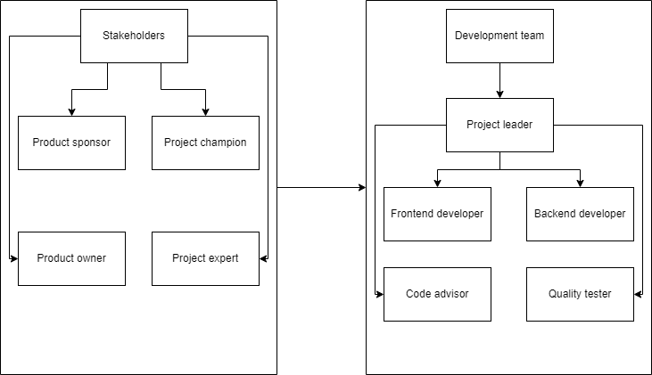

**Roles and responsibilities**

| Product Sponsor | Typically, the product sponsor is a high-level executive who provides financial support and an overall vision for the project through their involvement. It is their responsibility to ensure that the project is in line with the strategic objectives of the organization, to secure funding for the project, and to make sure that the project has all of the resources that it needs. |
| --- | --- |
| Product Owner | The product owner represents the end-users and stakeholders' interests. They are responsible for defining the project's goals, prioritizing the backlog of work, and ensuring that the development team understands the requirements. The product owner is the key decision-maker regarding what features the product will have. |
| Project champion | The project champion is an advocate for the project within the organization. They help in removing organizational barriers, facilitate necessary approvals, and work to maintain enthusiasm and support for the project across different departments. |
| Project expert | The project expert brings in-depth knowledge related to the project's subject matter. They provide technical or business expertise, guide the team on specific challenges, and ensure that the solution developed aligns with best practices and industry standards. |
| Project leader | The project leader is responsible for leading the project team and managing the day-to-day operations of the project. They plan, execute, and monitor the project, ensuring that team members are working effectively towards the project goals. |
| Backend developer | The backend developer focuses on server-side logic, integration of the user-facing elements developed by frontend developers, and database management. They are responsible for the functionality and scalability of the software or application. |
| Frontend developer | The frontend developer works on the user interface and user experience aspects of the software. They translate design and wireframes into interactive elements, ensuring that users have a seamless and efficient interaction with the product. |
| Code advisor | The code advisor, often an experienced developer or engineer, provides guidance on coding standards, reviews code for quality and efficiency, and helps in solving complex technical issues that the development team faces. |
| Quality tester | The quality tester is responsible for ensuring that the software product meets quality standards. They conduct various tests, identify bugs, and collaborate with developers to ensure that the final product is free of defects. |
|  |  |